Medicaid Provider Screening Portal - External Sources Integration Part 2
Deployment Guide

Revision History
Author | Revision Number | Date
TCSASSEMBER | 1.0 | 12.18.2012

Deployment Instructions 3
Organization of Submission 3
Application Setup 3
Build Scripts Setup 3
Configuration Files 4
Database Setup 4
Deployment Instructions 4
Starting 4
Verification 4
Resource Contact List 6
References 6

Deployment Instructions

This is an incremental build over the existing platform code, please refer to the existing deployment guides for the basic deployment procedure, this guide discusses only additional steps or configuration needed to deploy the new features added.

Organization of Submission

cms-external-sources – merged part 1 and part 2 and DMF/PECOS/NS services
cms-portal – the portal application code changes (the structure is not changed)
docs – contains this document and the external sources application deployment guide

Application Setup

- Oracle 11g
- JBoss 5.1.0.GA
- LDAP

Technologies:
- Jsoup
- Hibernate
- Web Services
- XSLT
- Drools

Build Scripts Setup

    - cms-portal/build.xml

Main targets:

build-core Builds the core archive
build-ejb Build the EJB archive
build-war Builds the web archive
clean Removes all generated files
deploy Deploys the portal ear artifact
deploy-ds Deploys the datasource definition to the application server
regenerate-model Regenerates the application model from the schemas
test Runs the portal tests

Default target: deploy

    - cms-portal/build.properties

jboss.home – the jboss home directory
jBPM.home – the local installation of JBPM 5.3
jboss.config – the jboss configuration to use
jdbc.url – the db server url
jdbc.user – db username
jdbc.pass – db password

Configuration Files

LDAP and database settings must be modified, Please see necessary configuration here

This assembly adds another property to

cms-portal/services/src/main/resources/cms.properties
# external sources integration
extsources.TEST.base=http://localhost:8180

You need to set it to the deployment base of the external sources application

Database Setup

- There are no additional tables and database setup for this assembly, please make sure you follow the external sources deployment guide and the portal deployment guide

Deployment Instructions

- Deploy the external sources application per its deployment guide in

docs/External Datasources Services Deployment Guide.doc

Please note that you cannot deploy the external source and the portal app in the same jboss instance as discussed here, so you either have to use multiple servers or deploy multiple instances

- Checkout the cms-portal code from the repository using rev. 223311
- Overlay cms-portal over this code
- Proceed to deploy the portal application as described here

Starting

- Start jboss for external services
- Start jboss for cms portal (not needed for unit tests)

Verification

The main function of the external sources in scope of this assembly is to verify individual and facility credentials of submissions, verify NPI in PECOS, verify NetStudy results and Verify exclusions, this is performed by the handler implementations:

gov.medicaid.process.enrollment.VerifyLicenseHandler
gov.medicaid.process.enrollment.VerifySSNHandler
gov.medicaid.process.enrollment.VerifyPECOSRecordHandler
gov.medicaid.process.enrollment.ExcludedProvidersScreeningHandler
gov.medicaid.process.enrollment.VerifyBackgroundStudyHandler

It uses the subclasses of BaseSOAPClient to perform this check which in turn maps the external service model to the internal representation using xslt files in

/services/src/main/resources/xslt/

The external sources are determined using the rules defined in

/cms-business-process/src/main/resources/cms.externalsources.drl

Some services may return multiple matches, or may require additional local filtering, this is implemented through a new interface defined:

gov.medicaid.domain.rules.inference.ResultMatchResolver

and its implementations, which are also configurable through the business rules.

Please note that some services are not needed:

- http://apps.topcoder.com/forums/?module=Thread&threadID=773654&start=0
MCP Service cannot be used by individual applicants

- http://apps.topcoder.com/forums/?module=Thread&threadID=773706&start=0
PDNO and PDNG Services perform the exact same thing (Class A License Verification) so only one is needed

- Execute ant test (make sure the external sources app is up – existing tests require a local email server)

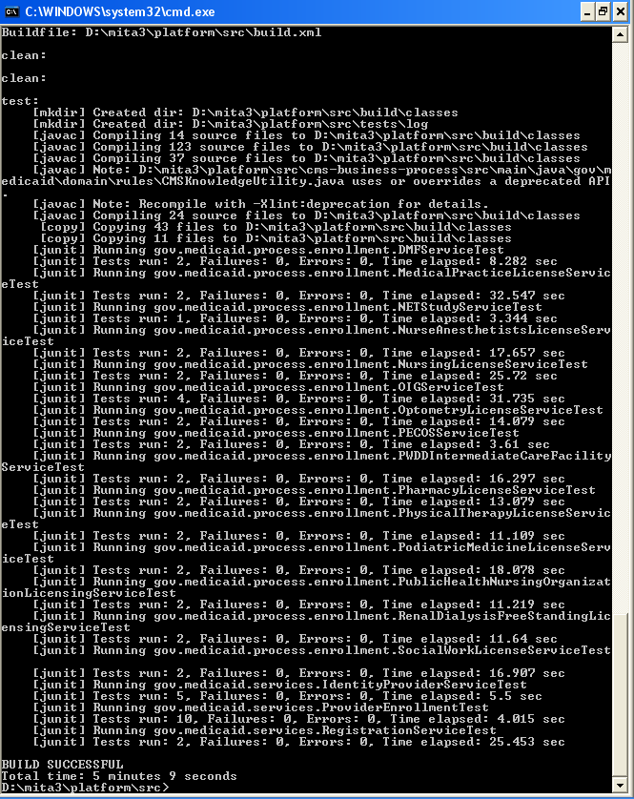

Resource Contact List

Name | Resource Email

References

CXF Installation
• https://community.jboss.org/wiki/JBossWS-Installation

- Download and extract v3.4.0 from http://www.jboss.org/jbossws/downloads
- Copy ant.properties.examples to ant.properties
- Modify ant.properties file accordingly. The most important properties are jboss510.home and jbossws.integration.target.
- Execute deploy for jboss 5.1.0

ant -Djboss.server.instance=default deploy-jboss510

